Team B1 – Network Structure

Reference model:

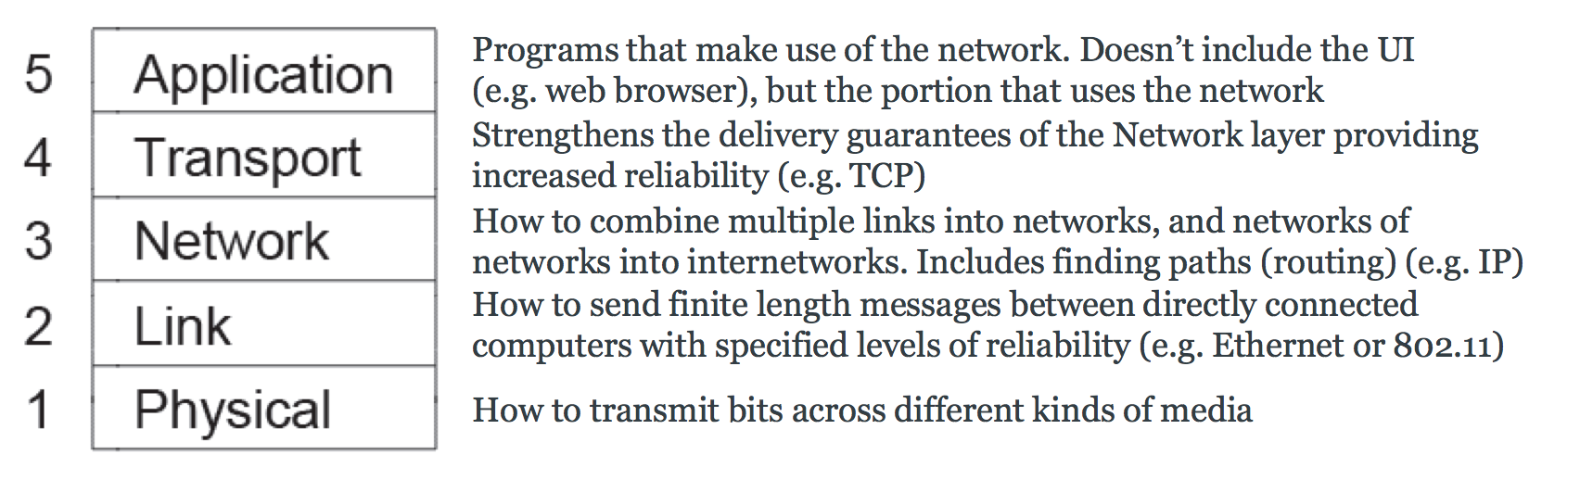

Application – All of us

What we have already:

* Mostly working physical layer (needs bugs fixing)

Possible Proposal:

* Application layer offers the UI (possibly a terminal on a computer) “to” and “message” fields
* Transport layer is similar to TCP (i.e., connection based) puts application data in to segments:
  + Implements handshaking
  + Checksums
  + Data integrity (e.g., Re-transmission of dropped packets)
* Network layer provides message routing, puts segments in to packets:
  + Routing tables etc
  + Knows which il mattos are connected to other ones
* Link layer deals with the connection and puts packets in to frames:
  + Data arriving in the correct order
  + Do we need to split in to LLC and MAC?
  + Acknowledged (similar to WiFi)
* Physical layer – just worries about the transmission of the data across the medium (mostly working already)

What we need to do:

* Choose what layers we need
* Decide functionality of each of our layers (and agree with team B2)
* Divide up the layers between us
* Decide on function prototypes for the services each layer will offer
* Do the shit tonne of work we’ll then have.
* Win all the marks